CRISIS SHORT TERM LOAN PROGRAM

Date: _________________________ County of Residence: ________________________

Applicant Name(s): _________________________________________________________________

Current Mailing Address: ____________________________________________________________

Email Address: _________________________ Phone: ____________________________________

The Purpose of our loans are to:
- Provide limited loan amounts with reasonable terms, low fixed rates, and no fees.
- No Credit checks.
- No hidden extra costs.
- No prepayment penalty.
- We do not require collateral.
- We DO consider the borrower’s ability to repay.
- We DO require that a monthly payment be made.
- We Do require a monthly check-in.
- We will utilize a Collection Agency for any past-due amounts and interest due. * They can pose any fees necessary

Program is for one assistance program at a time and only 1 per calendar year.
Case by Case basis

Do you have any outstanding Pay Day Loans, Same Day Loans, Cash/Check Advance Loans? YES/NO
If yes, indicate with whom, balance and payment plan: _________________________________________________________________________

Do you need help in identifying other resources for assistance:
YES/NO
If yes, explain: _____________________________________________________________

Must be willing to discuss household budget. Are you willing to commit to a monthly check-in?
YES/NO

2023 Application – Return To:
US Mail: WRH, P.O.BOX 314. Oregon, WI 53575 Fax 608-238-2084 Email: wrh2@wisconsinruralhousing.org
√ Check the box for the program you are applying for.
Loans to clients in crisis
 | Home Repair  detail your repair needs  provide estimate and/or invoice.  W-9 Form from Contractor required.  Assistance up to $1500 | Must be on Title  Owner Occupied  Must be primary residence  SUBMIT PROOF:  Property Taxes must be current  If you have a Mortgage, recent Statement
 | Car Repair  detail your repair needs  provide estimate and/or invoice.  W-9 Form from Auto Shop required.  Assistance up to $1000 | SUBMIT PROOF:  Must be on Title  Auto Insurance  If you have a loan, recent Statement
 | Medical Expenses  provide receipts, bills and/or invoices.  Assistance up to $500 | Uncovered expenses, co-payments, prescriptions, emergency transportation, Veterinary Bills,
Detail needs here (or supply on separate sheet of paper)

Application Guidelines.
- We must collect a completed application.
- Must have income verification for all household members over the age of 18. This includes unemployment, child support or other sources.
- Household Monthly income needs to be under 125% FPL (Federal Poverty Level). Household #1 $1519.00. Household #2 $2054.00 (2023 HHS Poverty Guidelines)
- You may apply for 1 type of assistance every year.
- Applications are typically processed within 7 business days.
- We will require certain conditions to be met before releasing the money. This will vary by applicant and situation.

2023 Application – Return To:
US Mail: WRH, P.O.BOX 314. Oregon, WI 53575 Fax 608-238-2084 Email: wrh2@wisconsinruralhousing.org
This is a Loan Program.
- The Loan will be subject to a Rate and Term and have a Monthly Obligation.
- Rates is as follows: 5%
- Term will be based on dollar amount and monthly affordability based on underwriting review. Term no greater than 2 years.
- We will provide an Amortization Schedule to the Applicant.
- Monthly Payments due by 15th of each month.
- Ability to pay by check, money order or electronically by Pay Pal.
- To reward those Applicants that have met our requirements and have made their full monthly payments in the month owed will have the last payment waived.

Sample Amortization Schedule:
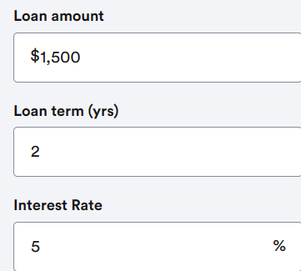

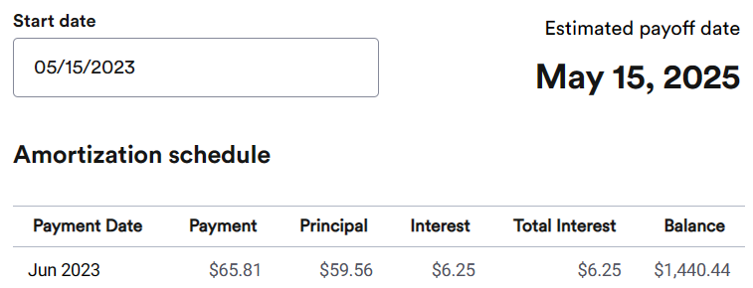

2023 Application – Return To:
US Mail: WRH, P.O.BOX 314. Oregon, WI 53575 Fax 608-238-2084 Email: wrh2@wisconsinruralhousing.org
Borrower  MEMBER #1 | Co Borrower  MEMBER #2 | Household  MEMBER #3 | Household  MEMBER #4
Full Name:  *Race: | Full Name:  *Race: | Full Name:  *Race: | Full Name:  *Race:
Ethnicity: Hispanic/Not Hispanic | Ethnicity: Hispanic/Not Hispanic | Ethnicity: Hispanic/Not Hispanic | Ethnicity: Hispanic/Not Hispanic
Date of Birth | Date of Birth | Date of Birth | Date of Birth
Disabled: Y N | Disabled: Y N | Disabled: Y N | Disabled: Y N
Total of people in household: | Relationship to Applicant | Relationship to Applicant | Relationship to Applicant
Male/Female/Other | Male/Female/Other | Male/Female/Other | Male/Female/Other
Rent /Own/ Other | Rent /Own/ Other | Rent /Own/ Other | Rent /Own/ Other
Veteran  Yes No | Veteran  Yes No | Veteran  Yes No | Veteran  Yes No
Are you working?  Yes No | Are you working?  Yes No | Are you working?  Yes No | Are you working?  Yes No
*I -AMERICAN INDIAN/ALASKA NATIVE A-ASIAN B-BLACK/AFRICAN AMERICAN P-NATIVE HAWAIIAN /PACIFIC ISLANDER W-WHITE 0-OTHER

You must have income to qualify for this program.
Must have income verification for all household members over the age of 18 living in the home.
Acceptable documentation includes most recent paystub, benefit letter, deposit records or a completed Employment Verification Form.
Monthly Income Source | Applicant | Adult 2 | Adult 3
Wages From Work
Child Support Received
W2
Pension/Retirement
Disability Payments
Unemployment
Self-Employment
Other
2023 Application – Return To:
US Mail: WRH, P.O.BOX 314. Oregon, WI 53575 Fax 608-238-2084 Email: wrh2@wisconsinruralhousing.org
MONTHLY EXPENSES
EXPENSES | AMOUNT PAID | EXPENSES | AMOUNT PAID
Rent / Mortgage |  | Student Loans
Lot Rent |  | Car Loan payments
HOA Fees/Condo Fees |  | Auto Insurance
Property Taxes |  | Fuel for vehicles
Homeowner Insurance |  | All Credit Cards
Water / Sewer |  | Unsecure Loans
Electric /Gas |  | Child Care Expense
Trash |  | Child Support Paid
Phone/Internet |  | Groceries
TV/Cable/Satellite |  | Educational Supplies
Subscriptions |  | Clothing Expense
Entertainment |  | Other Unexpected
Pay Day Loans |  | Other

2023 Application – Return To:
US Mail: WRH, P.O.BOX 314. Oregon, WI 53575 Fax 608-238-2084 Email: wrh2@wisconsinruralhousing.org
Foundation for Rural housing, Inc., complies with applicable laws and regulations for meeting Equal Opportunity Requirements under Equal Pay Act of 1963, Title VI and VII of the Civil Rights Act of 1964, Age Discrimination in Employment Acts of 1967 and 1975, Sections 503 and 504 of the Rehabilitation Act of 1973, Americans
with Disabilities Act (ADA) of 1990, and Wisconsin Fair Employment Act. You have the right to file a complaint if you are not satisfied with services provided by the agency, or if you have been discriminated against in employment or service delivery.
You can contact 1-888-400-5974 or email us at wrh2@wisconsinruralhousing.org.

I/We certify that the information provided in this application made by me and other household members and attachments are true, complete, and correct to the best of my/our knowledge. I/We further understand that false statements will void this application and disqualify me from receiving any housing assistance through the Foundation for Rural Housing, Inc., in the future.

Please Sign Below and Date
x
Borrower – print name here: Date

Please Sign Below and Date
x
Co- Borrower – print name here: Date

2023 Application – Return To:
US Mail: WRH, P.O.BOX 314. Oregon, WI 53575 Fax 608-238-2084 Email: wrh2@wisconsinruralhousing.org

